Annasaheb Dange College of Engineering and Technology, Ashta


Department of Computer Science and Engineering

Activity : Blog Writing

" Ransomware Detection using Machine Learning "

Name : Sneha Vijaykumar Sakri.
URN : 23031051
Roll No. : 3029
Class : TY – A
Under Guidance of : Prof. S. D. Khatavkar

Academic Year 2025 – 2026

Ransomware Detection using Machine Learning
Ransomware Attack has become one of those cyber threats that people often ignore until they experience it themselves. Imagine opening your system or device and suddenly finding that all your files are locked, with a message demanding money to restore and access it. This situation is no longer uncommon, as ransomware attacks now affect individuals, hospitals, companies, organisations and even governments. The major concern is that once files are encrypted Ransomware Attack has become one of those cyber threats that people often ignore until they means encoded, recovering them is extremely difficult and sometimes impossible without paying the amount to attacker or ransom. Because of this, there is a growing need to detect ransomware attack at an early stage, before it completes its attack. Instead of reacting after the damage has already occurred, modern cybersecurity aims to predict and stop such attacks in advance, and this is where deep learning plays a important role [1] [2].
Earlier, most cybersecurity systems worked using a signature-based approach. These systems maintained a database of known malware patterns and checked whether a file matched any of them or not. If a match was found, the system would block the file. However, attackers quickly learned to bypass these systems by slightly modifying their code, which changed the signature and made detection ineffective. Later, behavior based detection systems were introduced, which focused on monitoring what a program does rather than how it looks. Although this approach was an improvement, it still had limitations. These systems often generated too many false alerts or failed to detect complex ransomware behavior that unfolds over time. They lacked the intelligence to understand sequences of actions that together indicate an attack [3].
In today’s scenario, ransomware attacks follow a structured pattern rather than occurring randomly. For example, a ransomware program may first scan files, then access them rapidly, and finally encrypt them. If such sequences can be identified early, it becomes possible to stop the attack before any serious damage occurs. This need has led to the adoption of smarter detection methods that can learn from data instead of relying on fixed rules. Deep learning models, especially those designed to handle sequential data, are well suited for this task. These models can recognize patterns and relationships in a sequence of events, making them more effective at detecting ransomware behavior [4].
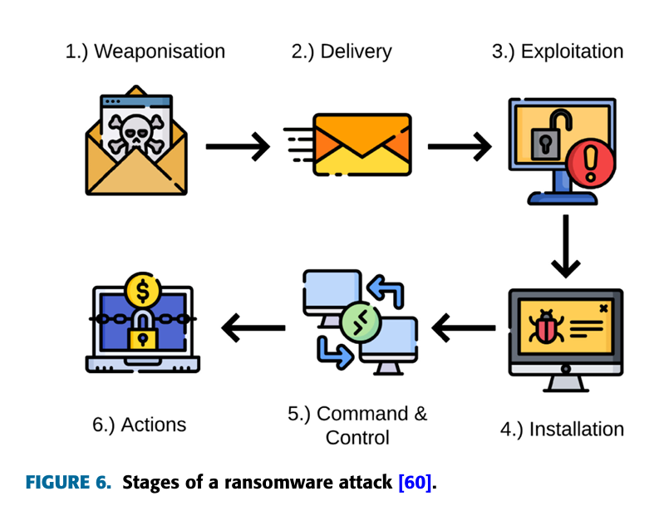
Stages of Ransomware Attack [5]

The proposed approach focuses on monitoring file system activities and identifying unusual patterns. In a normal scenario, users do not modify hundreds of files within a few seconds, but ransomware often performs such rapid and repetitive operations. By tracking activities like file creation, deletion, renaming, and modification, it is possible to capture a sequence of events over time. This sequence is then analyzed using a Long Short-Term Memory (LSTM) model, which is a type of deep learning model designed to understand time-based patterns. The LSTM model learns what normal system behavior looks like and compares it with ongoing activity. When it detects abnormal behavior, such as a sudden spike in file modifications, it flags it as suspicious. At that point, the system can either alert the user or automatically stop the process, preventing the ransomware from completing its encryption [5].
Application of Machine Learning Algorithms
The proposed system uses a Long Short-Term Memory (LSTM) model, a type of Recurrent Neural Network (RNN), designed for sequential data analysis.

Dataset and Preprocessing:
The system collects real-time file system activity such as:
- File creation
- File deletion
- File modification
- File renaming
These activities are recorded as time-series data. [6]

Preprocessing Steps:
- Data Cleaning: Removing incomplete or noisy records
- Normalization: Scaling feature values for better model performance
- Sequence Formation: Converting raw logs into time-based sequences
- Labeling: Marking data as normal or ransomware behavior
This ensures the dataset is suitable for training a machine learning model. [2]

Mathematical Justification
The LSTM model is effective because it can capture temporal dependencies in sequential data.
An LSTM unit consists of:
- Forget Gate:
Determines which information to discard
- Input Gate:
Decides which new information to store
- Output Gate:
Produces the final output

Mathematically:
- Forget Gate:
ft​=σ(Wf​⋅[ht−1​,xt​]+bf​)
- Input Gate:
it​=σ(Wi​⋅[ht−1​,xt​]+bi​)
- Candidate Memory:
C~t​=tanh(Wc​⋅[ht−1​, xt​]+bc​)
- Final Memory Update:
Ct​=ft​∗Ct−1​+it​∗C~t​
This allows the model to retain long-term dependencies, which is crucial because ransomware attacks occur as sequences of actions rather than isolated events. [7]

Analysis of Strengths and Weaknesses

Comparison of Algorithms:
Algorithm | Strengths | Weaknesses
Signature-Based | Fast detection | Cannot detect new variants
Behavior-Based | Detects unknown attacks | High false positives
Traditional ML (SVM, RF) | Good for structured data | Cannot handle sequences well
LSTM (Proposed) | Captures sequential patterns | Requires more data and computation

Model Evaluation and Tuning

Model performance is evaluated using Accuracy, Precision, Recall, and F1-Score.
High recall helps detect most ransomware attacks, while high precision reduces false alarms.
For improvement, hyperparameter tuning (like Grid Search) is used to adjust:
- Learning rate
- Number of LSTM layers
- Batch size
- Epochs
Result:
After tuning, the model achieves better accuracy, fewer false positives, and faster detection.

To implement this approach, a combination of practical and widely used technologies can be utilized. Python serves as the primary programming language due to its simplicity and strong support for machine learning. Frameworks like TensorFlow or PyTorch are used [1]to build and train the LSTM model. File monitoring can be performed using tools such as Windows Event Logs or Linux Auditd, which help track system activities in real time. Libraries like Pandas and NumPy assist in organizing and processing the collected data, while visualization tools like Matplotlib or dashboard interfaces can be used to display system behavior and alerts in an understandable way. Together, these tools create a complete system capable of detecting ransomware effectively [1].
In conclusion, ransomware is not just a technical issue but a serious real-world problem that can cause significant damage in a very short time. Traditional detection methods are no longer sufficient because cyber attackers constantly evolve their techniques. By using deep learning models such as LSTM, it becomes possible to move from reactive defense to proactive prevention. Monitoring file system behavior and analyzing it intelligently allows systems to detect ransomware at an early stage, thereby protecting data and reducing financial losses [2] [4].

References
[1] I. Goodfellow, Y. Bengio, and A. Courville, Deep Learning. Cambridge, MA, USA: MIT Press, 2016. [Online]. Available: https://www.deeplearningbook.org/
[2] A. Hussain et al., “Enhancing ransomware defense using deep learning,” PeerJ Computer Science, 2024. [Online]. Available: https://peerj.com/articles/cs-2546/
[3] R. Vinayakumar, K. P. Soman, and P. Poornachandran, “Applying deep learning approaches for network traffic prediction,” 2017. [Online]. Available: https://arxiv.org/abs/1709.02656
[4] J. S. Ruiz, “AI-powered ransomware detection: A comprehensive survey,” 2025. [Online]. Available: https://papers.ssrn.com/sol3/papers.cfm?abstract_id=5355456
[5] S. Hochreiter and J. Schmidhuber, “Long short-term memory,” Neural Computation, vol. 9, no. 8, pp. 1735–1780, 1997. [Online]. Available: https://doi.org/10.1162/neco.1997.9.8.1735
[6] D. Sgandurra, L. Muñoz-González, R. Mohsen, and E. C. Lupu, “Automated dynamic analysis of ransomware: Benefits, limitations and use for detection,” 2016. [Online]. Available: https://arxiv.org/abs/1609.03020

